**ARGO CD IMPLEMETATION**

Login to IBM Cloud using api key



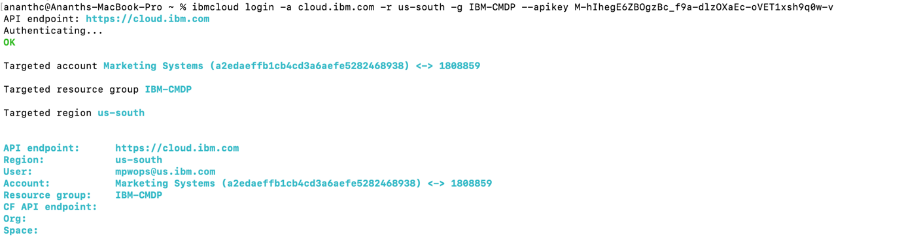

Login to the cluster





Check current cluster is configured and set the namespace

Get the list of pods running in the cluster

Sign in to argo server using kubernetes



Creation of DAGS

API docs

